Inward and Outward Curve Evolution
Using Level Set Method

Olivier Amadieu⁽¹⁾, Eric Debreuve⁽¹⁾, Michel Barlaud⁽¹⁾, Gilles Aubert⁽²⁾

⁽¹⁾Laboratoire I3S UPRES-A 6070 du CNRS, Université de Nice-Sophia Antipolis
Bâtiment Algorithmes/Euclide, 2000 route des Lucioles, Sophia Antipolis – 06410 BIOT, France
amadieu@i3s.unice.fr
⁽²⁾Laboratoire J.A. Dieudonné, UMR 6121 du CNRS, Université de Nice-Sophia Antipolis
Parc Valrose, 06108 Nice Cedex 2, France

Abstract
Iterative curve evolution techniques are powerful methods for image segmentation. Classical methods proposed curve evolutions which guarantee close contours at convergence and, combined with the level set method, they easily handled curve topology changes. However, these methods allow only one-way curve evolutions: shrinking or growing of the curve. Thus, the initial curve must encircle all the objects to be segmented or several curves must be used, each one totally inside one object.
In this paper, we present a new approach of iterative curve evolution using the level set method based on the variational criterion of an inverse problem. Besides the closing of the final contours and the curve topology change management, our method allows a two-way curve evolution: parts of the curve evolve in the outward direction while others evolve in the inward direction. It offers much more freedom in the initial curve position than with a classical geodesic search method. Our algorithm performs accurate and precise segmentations, with length penalty. Results are shown on damaged images with complex objects (including sharp angles, deep concavities or holes).

1. Introduction

One of the basic goals in image analysis is object segmentation. Among the different approaches in image segmentation, active contour model has emerged as a powerful tool for semi-automatic segmentation in still images. The objective is to define a force F so that the curve evolves until this force becomes null.
In an original work by Kass et al. in [6], “snakes” were proposed as parameterized planar curves based on an energy functional to minimize. This classical approach is based on deforming an initial contour or surface towards the boundary of objects to be detected. These active contours are examples of the general technique of matching deformable models to image data by means of energy minimization [6], [13].
The positive result of this approach is the closeness of the evolving curve towards objects. However, deforming a contour in this way shows several drawbacks. This energy model is not able of handling changes in the topology of the evolving contour when direct implementations are performed and, depending on the curve parameterization, the curve evolution is highly sensitive to the initial position of the snake. This initial guess should be reasonably close to the desired shape in order the final result to be accurate and precise.
PDE based curve evolutions [1] define a new “geometric” model. In this model, the evolution of active contour is motivated by a curve evolution approach and not an energy minimization one. The curve evolves according to a velocity F composed of three terms including a propagation term a that makes the curve shrink or expand towards boundaries, a regularization term, based on the curvature κ of the curve and finally, a data consistency term W(I), function of the I image. Thus, the PDE has the following expression:
$$\frac{∂C}{∂t}=W\left(I\right)\left(a+κ\right)\vec{N}$$ | (0)
One way to use this geometric model is to program this equation using the level set method [8,11]. In this method, the plane curve C is considered as the zero level set curve of a surface φ [2,5,7]. Such an implementation allows automatic changes in topology and then, the detection of several objects simultaneously is possible. If the planar curve evolves according to (0), then the embedding function $φ\left(x,t\right)$ deforms according to
$$\begin{aligned}\left\{φ_{t}=W\left(I\right) \left(a+κ\right) \left|∇φ\right| | \right.\end{aligned}$$
In [2], Caselles et al. obtain from an energy formulation a solution, which minimizes a weighted length. Adding to this solution a propagation term (“balloon force” for example [4]), considered as an additional area constraint [12] and using the level set method, they obtain the geodesic model.
Although these approaches can manage changes in topology, the sign of the speed expression remains constant. Indeed, the curve keeps evolving in only one direction, depending on the sign of the propagating term. This inconvenient may cause the non-detection of several objects and holes.
The purpose of our work is to define a new expression for the speed F, which must take into account all these drawbacks. In this way, we consider this evolution contour problem as an inverse problem. The proposed new curve evolution model is presented in Section 2. In Section 3, we explain how we obtain the new evolution speed expression, taking into account the discontinuities introduced in the model. Finally, in Section 4, we present some experimental results of applying our method to real images. These results show the effect of our new evolution speed, which allows inward evolution or outward evolution directions simultaneously for the same curve.

2. New Curve Evolution Model

2.1. Inverse Problem and Level Set Formulation

In this section, we propose a new method based on a geometric approach. The general scheme is a PDE approach with :
φ _{t}= F |∇φ|
where φ is an implicit representation of the curve C and F represents the evolving force. What is new in our work is how we deal with the evolving force.
The basic idea is to consider the curve evolution problem as an inverse problem [10]. Suppose we have a corrupted observation g of an image I through an operator A. This operator, is defined from Ω to Ω (where Ω is the definition domain of the image). A represents the observed data acquisition system. Let us follow some assumptions on the I model: it is composed of one or several objects having the same constant value I_{in}. The background has a constant value I_{out}.
$$I\left(x\right)=\begin{aligned}\left\{I_{\text{in}} \text{if} x∈D | \right.\end{aligned}$$ | (2)
where I_{in} and I_{out} are a priori constants and D is the set of regions corresponding to the objects to be detected.
The classical observation model is:
$$g=A\left(I\right)+η$$ | (3)
where η is a white noise and g the observed data.
The goal is to segment exactly the objects of I knowing only g. The problem is to find the D domain corresponding to our model (3). Thus, we search the boundaries of D as
$$∂D=\left\{x;φ\left(x\right)=0\right\}$$ | (4)
Using (3) and (4), we obtain the following problem: Search $φ$ so that:
$$\begin{aligned}\left\{J\left(I\right)=\underset{φ}{\text{min}}\int_{ℜ^{2}}{{\left(A\left(I\right)−g\right)}^{2}} | \right. \\ \end{aligned}$$ | (5)
In order to find the boundary ∂D, we use a dynamic method by defining a sequence of domains D_{t} so that D_{t} converges towards D, D the required solution. Then, we assume that:
$φ=φ\left(x,t\right)$ and $∂D_{t}=\left\{x;φ\left(x,t\right)=0\right\}$
We will now note ∂D_{t} as Γ(t).

B. Associated PDE

In our approach, the boundary Γ(t) corresponds to a curve C(p,t), with p the curve parameter, then:
$$Γ\left(t\right)=\left\{C\left(p,t\right);φ\left(C\left(p,t\right),t\right)=0\right\}$$ | (6)

Deriving this last expression with respect to t, we obtain:
$$φ_{t}+v∇φ=0$$ | (7)
where: $\vec{v}=\frac{∂C}{∂t}$is the speed of the curve.
We search this speed in the following form:
$$\vec{v}\left(x,t\right)=α\left(x,t\right) \vec{n}\left(x,t\right)$$ | (8)
where: $\vec{n}\left(x,t\right)=\frac{∇φ}{\left|∇φ\right|}\left(x,t\right)$
Using the expression of $\vec{v}$ from (8) in (7), we obtain a PDE curve evolution as in [2,5,9].
$$φ_{t}+α\left(x,t\right) \left|∇φ\right|=0$$ | (9)
The problem is now to compute the speed α(x,t) according to our model and to the criterion to minimize.

3. New Evolution Speed Expression

3.1. Criterion Minimization

The domain D is defined through a least mean square criterion as in [5]
$$F\left(t\right)=\int_{ℜ^{2}}{{\left[A\left(I\left(x,t\right)\right)−g\left(x\right)\right]}^{ 2}\text{dx}}$$ | (10)
where A is a linear or not operator, for example a convolution operator.
The goal is to find the speed expression α(x,t) so that F(t) is the most decreasing.
Since in our case, I(x,t) is a piecewise constant function as defined in (2), it involves discontinuities across $Γ\left(t\right)$. Thus, F(t) can not be derived in a classical sense. It has to be derived in the distributional sense. We will explain its first derivative development with respect to t in the following section.
As defined previously, D is the set of regions corresponding to the objects to be detected. In this way, we develop (10) as follows :
$$F\left(t\right)=\int_{D\left(t\right)}{\left(A I_{\text{in}}\left(x\right)−g\left(x\right)\right) ^{2}\text{dx}}+\int_{\bar{D}\left(t\right)}{\left(A I_{\text{out}}\left(x\right)−g\left(x\right)\right) ^{2}\text{dx}}$$ | (11)
$\bar{D}$ is the complementary of D in R², the set of regions without any object.

3.2. Evolution Speed Expression

Let us define ϕ =ϕ(t), a C∞ function with compact support on ]0;+∞[. The distributional derivative is defined as :
$$\left\langle F^{'}\left(t\right) , ϕ\left(t\right) \right\rangle =− \left\langle F\left(t\right) , ϕ^{'}\left(t\right) \right\rangle$$ | (12)

Then, using (11) and (12),
$$\begin{aligned}\left\langle F^{'}\left(t\right),ϕ\left(t\right) \right\rangle =−\int_{0}^{∞}{\left(\int_{D\left(t\right)}{{\left(A I_{\text{in}}\left(x\right)−g\left(x\right)\right)}^{2}\text{dx}}\right) ϕ^{'}\left(t\right)\text{dt}} \\ −\int_{0}^{∞}{\left(\int_{\bar{D}\left(t\right)}{{\left(A I_{\text{out}}\left(x\right)−g\left(x\right)\right)}^{2}\text{dx}}\right) ϕ^{'}\left(t\right)\text{dt}}\end{aligned}$$ | (13)

Let us define:
$$\begin{aligned}k_{\text{in}}\left(t\right)=\int_{D\left(t\right)}{{\left(A I_{\text{in}}\left(x\right)−g\left(x\right)\right)}^{2}}\text{dx} \\ k_{\text{out}}\left(t\right)=\int_{\bar{D}\left(t\right)}{{\left(A I_{\text{out}}\left(x\right)−g\left(x\right)\right)}^{2}}\text{dx}\end{aligned}$$ | (14)
using these expressions and then by integration by parts, we get :
$$\begin{aligned}\left\langle F^{'}\left(t\right),ϕ\left(t\right) \right\rangle =−\int_{0}^{∞}{k_{\text{in}}ϕ^{'}\left(t\right) \text{dt}}−\int_{0}^{∞}{k_{\text{out}}ϕ^{'}\left(t\right) \text{dt}} \\ =\int_{0}^{∞}{\left(k_{\text{in}}^{'}+k_{\text{out}}^{'}\right) ϕ\left(t\right) \text{dt}}−\left[\left(k_{\text{in}}+k_{\text{out}}\right) ϕ\left(t\right)\right] _{0}^{∞} ∀ϕ\end{aligned}$$
since ϕ has a compact support in $] 0,+∞ [$, we deduce
$F^{'}\left(t\right)=k_{\text{in}}^{'}\left(t\right)+k_{\text{out}}^{'}\left(t\right)$,
in a distributional sense. Using classical formula in (14):
$$\begin{aligned}k_{\text{in}}^{'}\left(t\right)=\int_{D\left(t\right)}{{\frac{∂}{∂t}\left(A I_{\text{in}}\left(x\right)−g\left(x\right)\right)}^{2}}\text{dx} \\ +\int_{Γ\left(t\right)}{{\left(A I_{\text{in}}\left(x\right)−g\left(x\right)\right)}^{2}} \vec{v}\text{.}\vec{n} dΓ\end{aligned}$$
since (A I_{in} - g) does not depend on t, the first term in k’_{in}(t) is null and similarly for k’_{out}(t) , so we get :
$$F^{'}\left(t\right)=\int_{Γ\left(t\right)}{\left({\left(A I_{\text{in}}−g\right)}^{2}−{\left(A I_{\text{out}}−g\right)}^{2}\right) \vec{v}\text{.}\vec{n} dΓ}$$ | (15)
from (8), we have $α\left(x,t\right)=\vec{v}\text{.}\vec{n}$ and finally, since ${\left|A\right|}^{2}=1$,
$$F^{'}\left(t\right)=\int_{Γ\left(t\right)}{α\left(x,t\right) \left( {\left(A I_{\text{in}}−g\right)}^{2}−{\left(A I_{\text{out}}−g\right)}^{2}\right) dΓ}$$ | (16)
Thus, considering this last expression, F(t) will decrease the most rapidly if
$$α\left(x,t\right)=−\left({\left(A I_{\text{in}}−g\right)}^{2}−{\left(A I_{\text{out}}−g\right)}^{2}\right) \text{on} Γ\left(t\right)$$ | (17)
As shown in this new expression, the evolution speed can now be either positive either negative. Indeed, the active contour will evolve by expanding or shrinking simultaneously on the same evolution process.

3.3. Length Penalty

As we will show in Section 4, the results we obtain by applying the evolution equation (18) are really precise and fit exactly with the boundaries of the objects to be detected. In specific applications, particularly in building images, objects are a priori known to be polyhedric. In this case, smooth curve would be more appropriate.
Indeed, in order to regularize the active contour, we add a length term to the initial criterion F(t) (10). The expression of the Euclidean length of the curve Γ(t) is
$$L=\oint{\left|Γ^{'}\left(q\right)\right|\text{dq}=\oint{\text{ds}}}$$
where s is the curvilinear parameter of the curve. Thus, the new criterion to minimize is
$$G\left(t\right)=\int_{ℜ^{2}}{{\left[A\left(I\left(x,t\right)\right)−g\left(x\right)\right]}^{ 2}\text{dx}}+\oint{\text{ds}}$$ | (19)
To minimize G(t) is equivalent to minimize the inverse problem error and the active contour length simultaneously. From the length term, we obtain the following PDE :
$$Γ_{t}=κ \vec{N}$$
where κ is the curvature of the curve.
Γ(t) represents the zero level set curve of the φ. surface. We derive this equation with respect to t and with an expression of the unit normal N function of the surface φ , we get :
$$φ_{t}=κ\left|∇φ\right|$$
Thus, this leads to the following curve evolution PDE :
$$φ_{t}+\left(α\left(x,t\right)+λ κ\right) \left|∇φ\right|=0$$ | (20)
where λ is a parameter that modifies the influence of the regularization. The expression of α(x,t) is given in (17). By applying this evolution equation (20), we get an image segmentation with curve length penalty

4. Experimental Results

In our approach, we consider the A operator as a convolution operator, for example a blurring Gaussian operator. The criterion results from our new curve evolution model using a level set method.
$$\begin{aligned}\left\{J\left(I\right)=\underset{φ}{\text{min}}\int_{ℜ^{2}}{{\left(A\left(I\right)−g\right)}^{2}}+\oint{\text{ds}} | \right. \\ \end{aligned}$$
To perform this curve evolution, we develop a specific numerical scheme for PDE (20).
In order to optimize time efficiency, we use the narrowband method [8], which allows us to perform calculations in the neighborhood of the contour and not in the whole image. For each application of our algorithm, parameter values to give are the weight λ for the regularization and the values I_{in} for the objects and I_{out} for the background.
The results are presented on a 300x300 digital laser model provided by Alcatel Corporate Research Center France and TopoSys GmbH Germany. On this data, the grey intensity corresponds to the height of the buildings on the scene. In our application, we consider this data as a grey level image. Such a high-resolution image is really easy to segment but on the other hand this kind of image is costly. In order to simulate a low resolution and cheap image, we blur, with a gaussian convolution mask, and then add some noise on this image.
In the two following examples we present a six images sequence showing the active contour evolution. Then, we display the final contour shape on the clear image to compare this contour with the boundaries of the objects.

4.1. Blurred Image

The Figure 1 shows the contour evolution with a weak regularization (λ=20). We observe an accurate segmentation with this new method. Every object and every hole they contain are accurately detected.

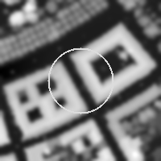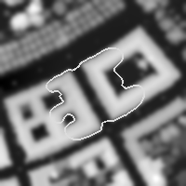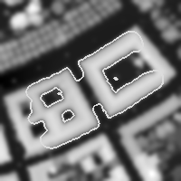

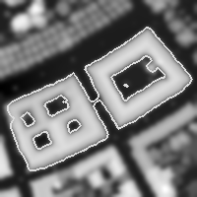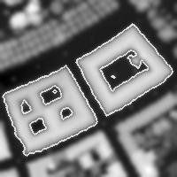

Figure 1. Curve evolution on a blurred real image

This main property of our approach is clearly shown. Indeed, parts of the curve evolve in the outward direction while others evolve in the inward direction. It results in two interesting properties.
First, it brings a much more important freedom in the choice of the initial curve. In Figure 1, the buildings are just cut by the curve and finally every part of them are well detected. On the contrary classical methods require to encircle all the objects to detect them or several curves had to be used inside of each object. Secondly, holes are easily and accurately detected even if the initial curve do not touch them.
Although the image is blurred (PSNR = 40.6 dB), objects are well detected. Figure 2 shows the final active contour shape fitting exactly with the boundaries of the buildings on the clear image. The weak regularization helps the contour to respect exactly these boundaries.

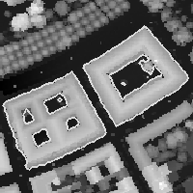

Figure 2. Final curve after process on blurred real image displayed on clear real image

4.2. Blurred and Noisy Image

Due to the high noise value (PSNR = 37.0 dB), we use in this case a more pronounced regularization (λ=400).
We observe a lack of precision especially concerning the boundaries of the patios particularly on angular zones.
This effect is shown on Figure 4 where the final contour obtained after a process on the blurred and noisy image is displayed on the clear image: the bottom left corners of buildings are eroded.

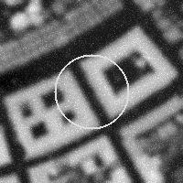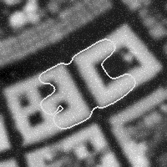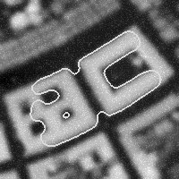

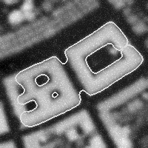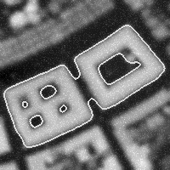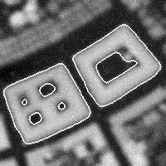

Figure 3. Curve evolution on blurred
and noisy real image

On the other hand, the sides of the contour fitting buildings are smoother than in the previous example.
Here, in spite of the noise, the length penalty of the curve leads to the detection of the two buildings and their patios evolution, see Figure 3. Moreover, the evolving curve has a better appearance since it is more “rigid”. This property is important if the image represent polyhedric shapes buildings.
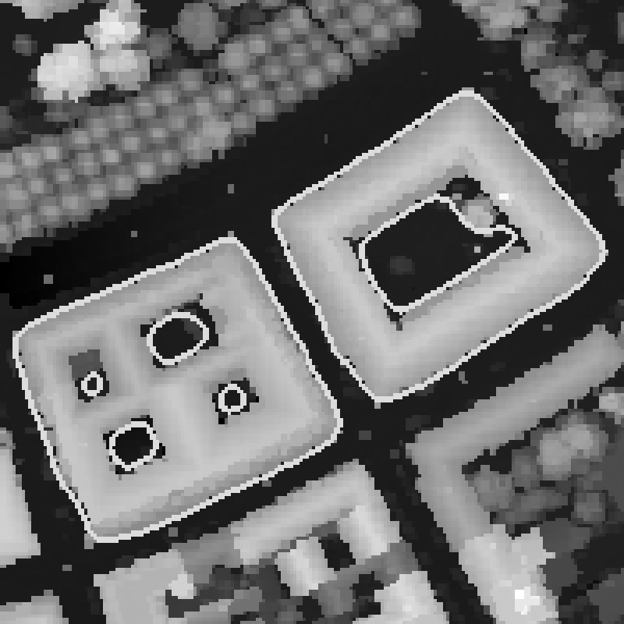

Figure 4. Final curve after process on blurred and noisy real image displayed on clear image

5. Conclusion

In this article, we have proposed a new approach of curve evolution iterative technique. This approach shows characteristics known in previous methods like the automatic changes in the topology of the curve or the closeness of the contours. Based on a variational criterion approach, our method defined a new expression for the speed evolution, which allows the contour to evolve with much more freedom, in the inward and in the outward direction simultaneously.
We have presented some results obtained with the proposed active contour method from digital surface model images. These results show the efficiency of our segmentation algorithm. Indeed, on each image, every object and hole is accurately segmented. This is the result of the properties of our new method.
Three major evolutions make the difference with above-mentioned methods. The first one concerns the expression of the speed evolution. The active contour evolve either in the inward or in the outward direction. This ability to be multidirectional allows the curve to fit exactly objects. The most important evolution obtained from this free evolution is the detection of holes.
The second one concerns the calculation. Our approach avoids the calculation of the gradient. In other methods, the gradient is used to perform a consistency data term W(I). The data used to perform our evolution speed expression is the intensity of the image itself.
The third advantage is the regularization of the contour sides obtained by adding a length penalty term. Our method regularize the active contour appearance and obtain precise and accurate segmentation from blurred and noisy images.

6. Acknowledgments

The authors would like to thank Alcatel Corporate Research Center, France and TopoSys GmbH, Germany, for providing high quality digital surface model Laser data and for authorizing the publication of these data.

7. References
- V. Caselles, F. Catte, T. Coll, and F. Dibos, “A geometric model for active contours”, Numer. Math., 1993, vol. 66, pp. 1-31.
- V. Caselles, R. Kimmel, and G. Sapiro, “Geodesic active contours”, Proc. 5th Int. Conf. on Computer Vision, 1995, pp. 694-699.
- L. Cohen, “On active contour models and balloons”, Computer Vision, Graphics and Image Processing : Image Understanding, Vol. 53 N°2, 1991, pp. 211-218.
- E. Debreuve, M. Barlaud, G. Aubert, and J. Darcourt, “Attenuation map segmentation without reconstruction using a level set method in nuclear medecine imaging,” Int. Conf. Image Proc., 1998.
- E. Debreuve, M. Barlaud, G. Aubert, I. Laurette and J. Darcourt, “Space Time Segmentation using Level Set Active Contours Applied to Myocardial Gated SPECT” Proceedings of Medical Imaging Conference, Seattle 1999.
- M. Kass, A. Witkin, and D. Terzopoulos “Snakes: Active contour models,” Int. J. Comput. Vis., vol. 1, Jan. 1988, pp. 321-332.
- R. Malladi, J. A. Sethian, and B. C. Vemuri, “Evolutionary fronts for topology independent shape modelling and recovery,” Proc. 3rd Int. Conf. Comput. Vision, 1994.
- R. Malladi, J. A. Sethian, and B. C. Vemuri, “Shape modeling with front propagation: A level set approach,” IEEE Trans. Pattern Anal. Machine Intell., vol. 17, 1995, pp. 158-175.
- S. Osher and J. A. Sethian, “Fronts propagating with curvature dependent speed: Algorithms based on the Hamilton-Jacobi formulation,” J. Comput. Phys., vol. 79, 1988, pp. 12-49.
- Santosa, “A level set approach for inverse problems involving obstacles” ESAIM:Control Optimization and Calculus of Variations, 1996.
- J.A. Sethian, Level Set Methods, Cambridge University Press, 1996.
- K. Siddiqi, Y. Bérubé Lauzière, A. Tannenbaum, “Area and length minimizing flows for shape segmentation,“ IEEE Trans. Image Processing, vol. 7, 1998, pp. 433-443.
- D. Terzopoulos, A. Witkin, and M. Kass “Constraints on deformable models:Recovering 3D shape and non rigid motions,” Artificial Intelligence, 1988.

